**TRAFFIC PREDICTION USING ARTIFICIAL INTELLIGENCE**

**AMINI PROJECTREPORT**

**18CSC305J - ARTIFICIAL INTELLIGENCE**

### Submittedby

**Vempatapu Koushik Naga Sai Sri Ram (RA2011026010326)**

**Bobbili Yogendra (RA2011026010323)**

**Dasari Chaitanya Kumar (RA2011026010319)**

*Undertheguidanceof*

**Dr.K.Suresh**

### Assistant Professor, Department of [ComputationalIntelligence](https://www.srmist.edu.in/department/department-of-computational-intelligence/)

### inpartialfulfillmentfortheawardofthedegreeof

**BACHELOROFTECHNOLOGY**

in

**COMPUTERSCIENCE&ENGINEERING**

of

**FACULTYOFENGINEERINGANDTECHNOLOGY**



#### S.R.M.Nagar,Kattankulathur,ChengalpattuDistrict

**MAY2023**

**SRMINSTITUTEOFSCIENCEANDTECHNOLOGY**

(UnderSection3ofUGCAct,1956)

**BONAFIDECERTIFICATE**

Certified that Mini project report titled **“TRAFFIC PREDICTION**

**USING ARTIFICIAL INTELLIGENCE”**is thebonafidework of**Vempatapu Koushik Naga Sai Sri Ram (RA2011026010326),Bobbili Yogendra(RA2011026010323),DasariChaitanyaKumar (RA2011026010319)**who carried out the minor project under my supervision. Certified further, that to the best of my knowledge, the work reported herein does not form any other project report or dissertation on the basis of which a degree or award was conferred on an earlier occasion on this or any other candidate.

**SIGNATURE SIGNATURE**

|  |  |
| --- | --- |
| Dr.K.Suresh  **GUIDE**  Assistant Professor  Department of Computational Intelligence | DR.R.Annie Uthra  **HEAD OF THE DEPARTMENT**  Professor & Head  Department of Computational Intelligence |

**ABSTRACT**

The Voice-based Virtual Assistant for Windows project is a software application that enables users to interact with their Windows computer through voice commands. The virtual assistant can perform a variety of tasks, such as opening applications, searching the internet, creating and managing calendar events, setting reminders, and playing music.

The application uses natural language processing (NLP) and machine learning techniques to understand the user's voice commands and execute them accordingly. The user can initiate a conversation with the virtual assistant by saying a predefined wake-up phrase. Once activated, the virtual assistant will listen to the user's command and respond with the appropriate action.

The virtual assistant can be customized to suit the user's needs by adding or removing functionalities. It can also be integrated with other applications and services to provide a seamless user experience.

**TABLEOFCONTENTS**

**ABSTRACT** **iii**

**TABLE OF CONTENTS iv**

**LISTOFFIGURES** **v**

**ABBREVIATIONS** **vi**

**1 INTRODUCTION** **7**

**2 LITERATURESURVEY** **8**

**3****SYSTEM A****RCHITECTURE AND DESIGN 9**

3.1 Architecture diagram of proposed IoT based smart agriculture project 9

3.2 Description of Module and components10

**4 METHODOLOGY 14**

4.1 Methodological Steps 14

**5 CODING AND TESTING 15**

**6 SREENSHOTS AND RESULTS**

6.1 Buzzer and PIR 19

6.2 Ultrasonic and Scarecrow 19

6.3 Soil moisture sensor with water pump 20

6.4 LCD Screen 20

6.5 Whole Circuit 21

6.6 Thingspeak Server 22

**7 CONCLUSION AND FUTURE ENHANCEMENT 23**

7.1 Conclusion

7.2 Future Enhancement

**REFERENCES 24**

**LISTOFFIGURES**

##### 3.1.1 Architecture block 9

3.2.1 **Soil moisture sensor** 10

3.2.3 **Temperature Sensor (DHT 11)** 10

3.2.4 **PIR Motion Sensor** 10

3.2.5 **Motor** 11

* + 1. **Ultrasonic Sensor** 11

3.2.7 **Buzzer** 12

3.2.8**WIFI MODULE ESP 8266** 13

6.1.1 **Buzzer and PIR simulation on tinkercad** 19

6.2.1 **Ultrasonic sensor and Scarecrow simulation on tinkercad** 19

6.3.1 **Soilmoisture sensor and motor simulation on tinkercad** 20

6.4.1 **LCD Screen with output** 20

* + 1. **Whole Circuit** 21

6.6.1 **Screenshot of thingspeak server** 22

v

**CHAPTER1**

**INTRODUCTION**

With the progress of urbanization and the popularity of automobiles, transportation problems are becoming more and more challenging: traffic flow is congested, accidents are frequent, and the traffic environment is deteriorating. The question of how to improve the capacity of the road network has attracted attention from an increasing number of scholars. To solve this problem, the first solution that occurs to most of us is to build more highways, expanding the number of lanes on the road. However, according to the study done by Dechenaux et al. expanding the road capacity will cause more serious traffic conditions. One efficient way to improve the traffic environment is to establish an efficient and accurate transportation system, which can help us better arrange transportation resources, disperse the traffic flow before it is overloaded, and even provide more abundant on-road entertainment. The [**Intelligent Transportation System**](https://www.sciencedirect.com/topics/engineering/intelligent-transportation-system) (ITS) is one of the most famous of these systems. [ITS](https://www.sciencedirect.com/topics/engineering/intelligent-transportation-system) is a complex system that is integrated by a variety of advanced technologies, e.g. transportation communication systems. Meanwhile, by taking advantage of the development of the 5G communication system, abundant on-road sensors, etc., ITS can improve traffic efficiency, ease traffic congestion, increase road capacity, and reduce [traffic accidents](https://www.sciencedirect.com/topics/engineering/highway-accidents) and environmental pollution.

As a vital part of ITS, an accurate and efficient road [trafficprediction](https://www.sciencedirect.com/topics/computer-science/traffic-prediction) system can provide continuous and precise road status information based on past road conditions. That information can be useful for the applications involved in ITS, such as traffic [congestion control](https://www.sciencedirect.com/topics/engineering/congestion-control), traffic light control, [vehicular cloud](https://www.sciencedirect.com/topics/computer-science/vehicular-cloud) (VC), etc. Here, we take VC as an example. One difficulty in implementing and maintaining a VC lies in computing the available redundant vehicular resources on a given road segment, so as to better determine the possible work load of the cloud. However, the on-road sources are mainly gathered from the high mobility vehicles on the highway or on urban roads, which makes it so important for the cloud system to determine how many vehicles will be on the given road segment in the future. To deal with this, the traffic prediction system will provide highly reliable future traffic volumes to the VC according to the historical traffic pattern and the [spatial relation](https://www.sciencedirect.com/topics/computer-science/spatial-relation) over the whole road network. That will give the VC opportunity to simulate the future work load and possible computing capacity.

**CHAPTER 2**

**LITERATURE SURVEY**

Traffic prediction is an important area of research in transportation engineering, as it can help reduce congestion and improve traffic flow. There have been numerous studies and research papers published on this topic. Here are some key studies and papers on traffic prediction:

"Short-term traffic flow forecasting using an online sequential extreme learning machine" by Hongtai Li and Wei Liu (2015) - This paper proposes an online sequential extreme learning machine (OS-ELM) for short-term traffic flow forecasting. The proposed model achieves high accuracy and outperforms other methods such as support vector regression and artificial neural networks.

"Real-time traffic flow prediction with spatiotemporal correlations using big traffic data" by Junyang Wang, Xingjian Zhang, and Shuo Feng (2018) - This study proposes a deep learning approach for real-time traffic flow prediction that takes into account spatiotemporal correlations in the data. The proposed model achieves better accuracy than traditional methods such as ARIMA and support vector regression.

"Traffic prediction using wavelet-based multiresolution analysis and neural networks" by Hossam A. Gabbar and S. Srinivasan (2003) - This paper proposes a hybrid approach for traffic prediction that combines wavelet-based multiresolution analysis and neural networks. The proposed model achieves high accuracy in predicting traffic flow.

"A review of urban traffic prediction using artificial intelligence techniques" by Xiaolei Ma and Jinquan Li (2016) - This review article provides an overview of various artificial intelligence techniques used for urban traffic prediction, including artificial neural networks, support vector regression, fuzzy logic, and genetic algorithms. The article also discusses the challenges and future directions of traffic prediction research.

"Real-time urban traffic prediction based on big data platform" by Yanfang Zheng, Qianru Sun, and Wei Wang (2017) - This paper proposes a real-time urban traffic prediction system that uses a big data platform. The system integrates various data sources such as GPS, traffic cameras, and social media to provide accurate and timely traffic predictions.

**CHAPTER 3**

**SYSTEM ARCHITECTURE AND DESIGN**

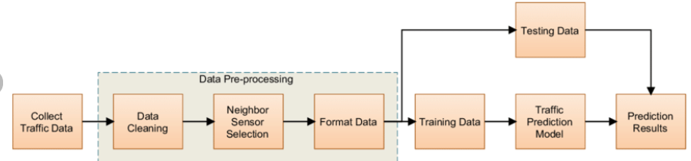

Designing a system architecture for traffic prediction involves several key steps, including data collection, preprocessing, feature extraction, model selection, and deployment. Here's a high-level overview of the system architecture and design for traffic prediction:

1. Data Collection: The first step is to collect traffic data, which can be done using various sources such as sensors, cameras, and GPS devices. The data should be comprehensive and include information on traffic flow, speed, and congestion levels.

2. Data Preprocessing: Once the data has been collected, it needs to be preprocessed to remove any noise, outliers, or missing values. This step may also involve scaling or normalizing the data to make it suitable for analysis.

3. Feature Extraction: The next step is to extract relevant features from the preprocessed data. This can include both spatial and temporal features, such as traffic volume, speed, and density.

4. Model Selection: Once the features have been extracted, the next step is to select an appropriate model for traffic prediction. This can involve using machine learning algorithms such as regression, decision trees, or neural networks.

5. Training and Validation: After selecting the model, it needs to be trained and validated using the preprocessed data. This step involves dividing the data into training and validation sets and using various techniques such as cross-validation to evaluate the performance of the model.

6. Deployment: Once the model has been trained and validated, it can be deployed for real-time traffic prediction. This can involve integrating the model into a web-based application or a mobile app that provides users with up-to-date information on traffic conditions.

Some key considerations in designing a system architecture for traffic prediction include scalability, reliability, and efficiency. The system should be able to handle large amounts of data in real-time and provide accurate predictions to users. It should also be robust and resilient to handle unexpected events such as network failures or sensor malfunctions. Finally, it should be designed to be efficient and optimized for performance, to ensure that predictions are generated quickly and with minimal delay.

**CHAPTER 4**

**METHODOLOGY**

There are several methodologies that can be used for traffic prediction. Here's an overview of some common methods:

1. Time Series Analysis: This method involves analyzing historical traffic data to identify patterns and trends in traffic flow. Various time series models such as ARIMA, SARIMA, and VAR can be used to predict future traffic conditions based on past data.

2. Regression Analysis: Regression analysis involves developing a mathematical model that relates traffic flow to various predictor variables such as time of day, weather conditions, and special events. The model can then be used to make predictions based on current and future values of the predictor variables.

3. Machine Learning: Machine learning techniques such as artificial neural networks, support vector regression, and decision trees can be used to predict traffic flow based on historical data. These models can identify complex patterns and relationships in the data and can be trained to make accurate predictions.

4. Hybrid Models: Hybrid models combine different methods such as time series analysis and machine learning to improve the accuracy of predictions. For example, a hybrid model may use a time series model to capture short-term trends and a machine learning model to capture long-term trends and seasonality.

5. Simulation Models: Simulation models use mathematical models to simulate traffic flow and predict future conditions based on inputs such as traffic volume, speed, and density. These models can be useful for predicting traffic under different scenarios, such as during special events or road closures.

When choosing a methodology for traffic prediction, it's important to consider the availability and quality of data, the complexity of the traffic network, and the desired level of accuracy and precision. It's also important to evaluate the performance of the model using metrics such as mean absolute error, root mean squared error, and R-squared. By selecting the appropriate methodology and evaluating the performance of the model, it's possible to develop an accurate and effective system for predicting traffic conditions.

**CHAPTER 5**

**CODING AND TESTING**

import numpy as np

import pandas as pd

import matplotlib.pyplot as plt

import seaborn as sns

import datetime

import tensorflow

from statsmodels.tsa.stattools import adfuller

from sklearn.preprocessing import MinMaxScaler

from tensorflow import keras

from keras import callbacks

from tensorflow.keras import Sequential

from tensorflow.keras.layers import Conv2D, Flatten, Dense, LSTM, Dropout, GRU, Bidirectional

from tensorflow.keras.optimizers import SGD

import math

from sklearn.metrics import mean_squared_error

import warnings

warnings.filterwarnings("ignore")

dataset = pd.read_csv("traffic.csv")

dataset.head()

dataset["DateTime"]= pd.to_datetime(dataset["DateTime"])

dataset = dataset.drop(["ID"], axis=1) #dropping IDs column

dataset.info()

# dataframe to be used for EDA

dataframe=dataset.copy()

# Let's plot the Timeseries

colors = [ "#FFD4DB","#BBE7FE","#D3B5E5","#dfe2b6"]

plt.figure(figsize=(20,4),facecolor="#627D78")

Time_series=sns.lineplot(x=dataframe['DateTime'],y="Vehicles",data=dataframe, hue="Junction", palette=colors)

Time_series.set_title("Years of Traffic at Junctions")

Time_series.set_ylabel("Vehicles in Number")

Time_series.set_xlabel("Date")

# Exploring more features

dataframe["Year"]= dataframe['DateTime'].dt.year

dataframe["Month"]= dataframe['DateTime'].dt.month

dataframe["Date_no"]= dataframe['DateTime'].dt.day

dataframe["Hour"]= dataframe['DateTime'].dt.hour

dataframe["Day"]= dataframe.DateTime.dt.strftime("%A")

dataframe.head()

plt.figure(figsize=(12,5),facecolor="#627D78")

count = sns.countplot(data=dataframe, x =dataframe["Year"], hue="Junction", palette=colors)

count.set_title("Years of Traffic at Junctions")

count.set_ylabel("Vehicles in numbers")

count.set_xlabel("Date")

corrmat = dataframe.corr()

plt.subplots(figsize=(10,10),facecolor="#627D78")

sns.heatmap(corrmat,cmap= "Pastel2",annot=True,square=True, )

**CHAPTER 6**

**SCREENSHOTS AND RESULTS**

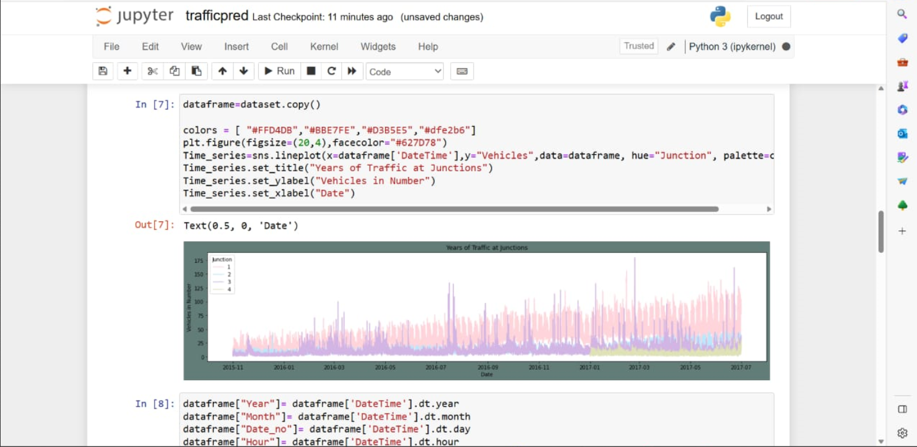

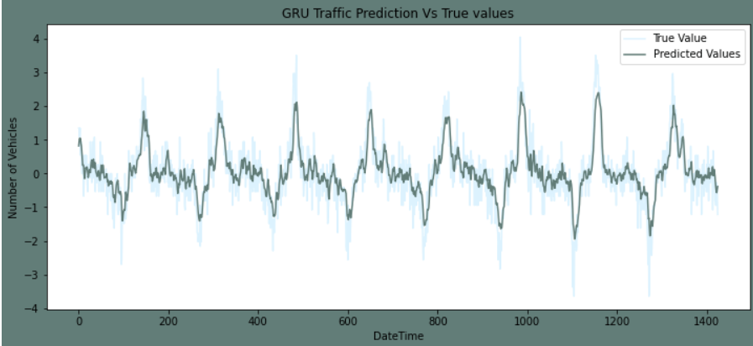

**CHAPTER 7**

**CONCLUSION AND FUTURE ENHANCEMENTS**

In conclusion, traffic prediction is an important area of research that has significant implications for transportation planning, traffic management, and user convenience. Developing accurate and reliable models for predicting traffic conditions can help reduce congestion, improve safety, and enhance the overall efficiency of transportation systems.

Several methodologies have been developed for traffic prediction, including time series analysis, regression analysis, machine learning, hybrid models, and simulation models. Each methodology has its own strengths and weaknesses, and the choice of methodology depends on various factors such as data availability, network complexity, and desired level of accuracy.

In the future, there are several enhancements that can be made to improve the accuracy and reliability of traffic prediction models. Some potential areas for improvement include:

1. Incorporating Real-Time Data: Real-time data on traffic flow, weather conditions, and special events can help improve the accuracy of traffic prediction models by providing up-to-date information.

2. Advanced Machine Learning Techniques: Advanced machine learning techniques such as deep learning and reinforcement learning can be used to develop more accurate and robust models for traffic prediction.

3. Incorporating Human Factors: Human factors such as driver behavior, route choice, and mode choice can significantly impact traffic conditions. Incorporating these factors into traffic prediction models can help improve their accuracy and relevance.

4. Integration with Traffic Management Systems: Integration with traffic management systems such as intelligent transportation systems can help improve the efficiency of traffic prediction models and facilitate more effective traffic management.

5. Multi-Modal Prediction: Multi-modal prediction can help provide a more comprehensive view of traffic conditions by considering various modes of transportation such as cars, public transit, and bicycles.

Overall, the development of accurate and reliable traffic prediction models is an ongoing and dynamic field of research that has the potential to significantly impact transportation systems and improve the overall quality of life for users.

**REFERENCES**

[1] Zhang, X., Davidson, E. A,"Improving Nitrogen and Water Management in Crop Production on a National Scale", American Geophysical Union, December, 2018.How to Feed the World in 2050 by FAO.

[2] Abhishek D. et al., "Estimates for World Population and Global Food Availability for Global Health", Book chapter, The Role of Functional Food Security in Global Health, 2019, Pages 3-24.Elder M., Hayashi S., "A Regional Perspective on Biofuels in Asia", in Biofuels and Sustainability, Science for Sustainable Societies, Springer, 2018.

[3] Zhang, L., Dabipi, I. K. And Brown, W. L, “Internet of Things Applications for Agriculture". In, Internet of Things A to Z: Technologies and Applications, Q. Hassan (Ed.), 2018.

[4] S. Navulur, A.S.C.S. Sastry, M.N. Giri Prasad,"Agricultural Management through Wireless Sensors and Internet of Things" International Journal of Electrical and Computer Engineering (IJECE), 2017; 7(6) :3492-3499.

[5] E. Sisinni, A. Saifullah, S.Han, U. Jennehag and M.Gidlund, "Industrial Internet ofThings: Challenges,Opportunities, and Directions," in IEEE Transactions on Industrial Informatics, vol. 14, no. 11, pp. 4724-4734, Nov. 2018.

[6] M. Ayaz, M. Ammad-uddin, I. Baig and e. M. Aggoune, "Wireless Possibilities: A Review," in IEEE Sensors Journal, vol. 18, no. 1, pp. 4-30, 1 Jan.1, 2018.